Project Design Phase
Solution Architecture
Date | November 2026
Student Name | Rachabathula Gnana Sruthi
Project Name | Automated Network Request Management
Maximum Marks

Solution Architecture
The architecture bridges the employee-facing portal experience with ServiceNow application configuration, validation rules and the backend Employee Raise Issue table.
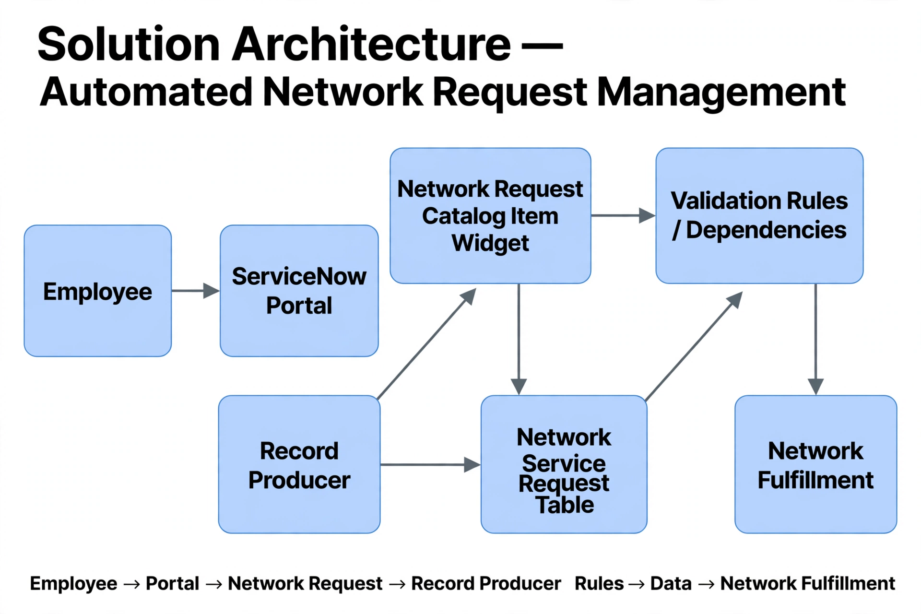

Layer | Components | Responsibility
Experience | Service Portal (/sp), homepage, network widgets, catalog items. | Employee network service submission UI.
Interaction | Client Script / AngularJS | Redirect from widget to Record Producer and handle form interaction.
Catalog | Network Request Record Producer | Collect structured network parameters and map to backend table.
Rules | UI Policies and dependency choices | Validate network parameters and control field visibility dynamically.
Data | Custom Table (u_network_requests) | Persist network request records and audit trails.
References | sys_user, sys_user_group | Reference data for requesters, managers, and assignment groups.

